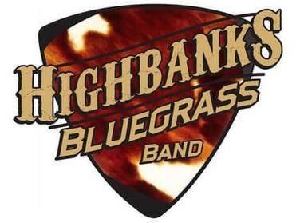

Come on out for some great bluegrass music!

**The HighBanks Bluegrass Band**

(thehighbanksband.com)

**Comments Here**

**See you there!**

**Location Here**

**Address Here**

**Date and Time Here**

